1. Install Git on your system, open a terminal or command prompt, and run git --version to confirm the installation.
2. Initialize a new local Git repository named music-recommendation in a folder, create a README.md file inside it, and make your first commit with the message 'Initial commit for music-recommendation project'.
3. Create a new GitHub repository called foodie-favorites, connect your local music-recommendation repository to this remote using git remote add origin, and push your commits to GitHub. git push -u origin main (or master) after connecting the remote.
4. Simulate a team collaboration: Edit your README.md to add a section called 'Top 3 Music Apps' (e.g., Spotify, YouTube Music, Wynk), commit the change, and push it to your GitHub repository. Then, use the GitHub website to create an Issue suggesting a new feature for your project (e.g., 'Add playlist sharing').
5. Write a short note (3-4 lines) explaining how using Git and GitHub can help you avoid the problem of having multiple versions of the same Jupyter notebook file (like analysis_v1.ipynb, analysis_final2.ipynb, etc.) when working on a data science project.

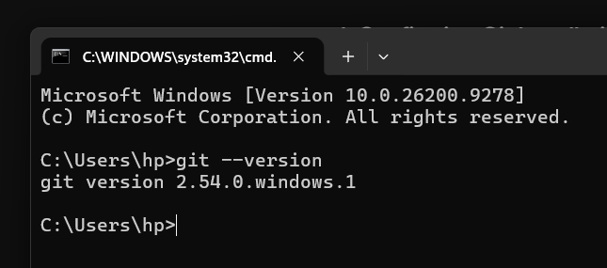

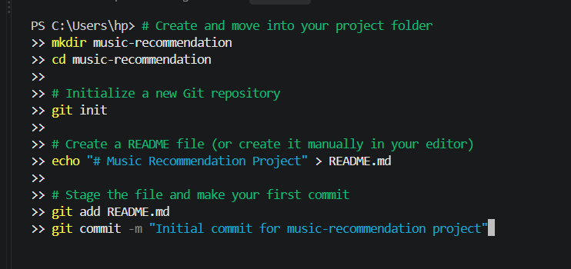

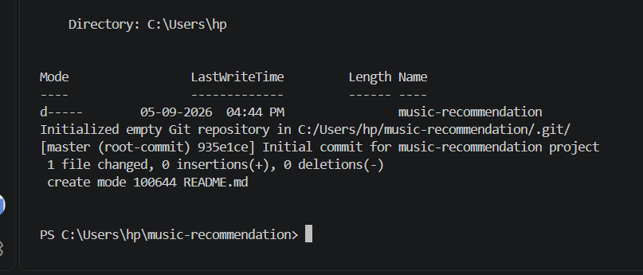

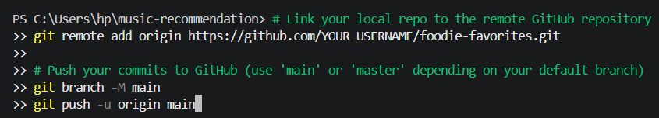

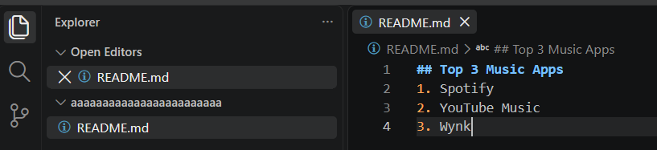

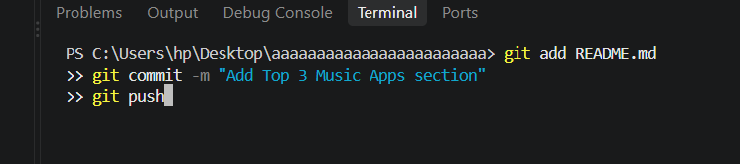

5. Why Git Replaces Cluttered Version Files
Using Git and GitHub eliminates the need for messy file naming conventions like analysis_v1.ipynb or analysis_final_final.ipynb by tracking every change as a distinct history log inside a single file. Instead of saving duplicate copies, you can effortlessly switch between different versions, compare changes side-by-side, and collaborate with teammates seamlessly on the exact same notebook without overwriting each other's work.

